Figures and Tables

Figure 1: Using landing tickets we aggregated to catch to trips and defined realized fisheries. Using these realized fisheries we measured vessel and port level fisheries diversification.

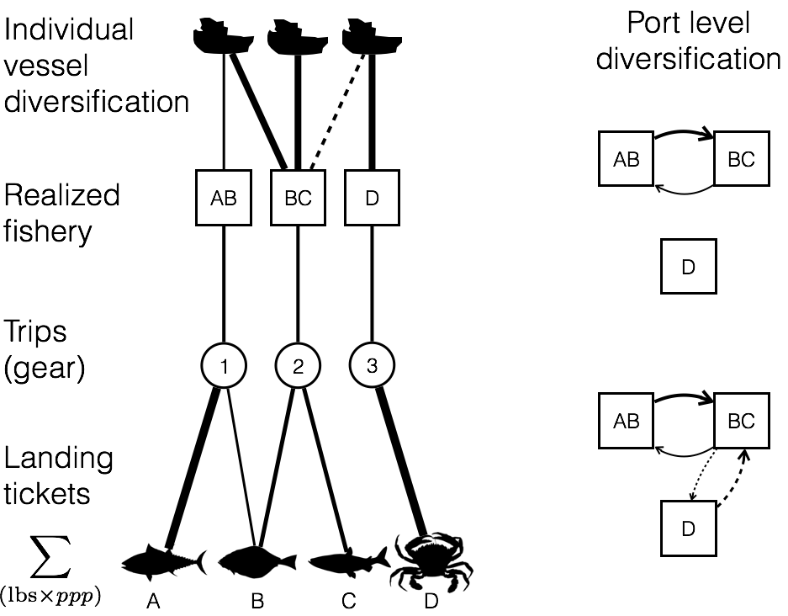

Table 1: We summarize fleet characteristics for three realized fisheries and compare to the corresponding NWFSC Observer sector description. Parenthetical values represent the percentage of trips which fell within expected ranges. The following fisheries represent (with pink shrimp and limited entry groundfish) the top ten realized fisheries by revenue. Fleet characteristics for which no corresponding NWSFC observer sector is present are presented as 95 percentiles for length, latitude and seasonality.

|  |  |  |  |  |
| --- | --- | --- | --- | --- |
| **Fishery**  Sector name if applicable | **Latitude**  decimal degrees | **Catch composition**  % trips multispecies | **Seasonality**  fishing season | **Vessel Length**  ± 1 ft |
| Limited entry groundfish trawl/catch shares | 35.4-49  (97.9%) | 100%  (98.2%) | year-round | 35-95  (99.5%) |
| Pink shrimp trawl | 35.8-49  (97.9%) | NA | Apr 1 – Oct 31  (99.8%) | 38-105  (100%) |
| California halibut trawl | 37.4 – 34.05  (96.5%) | CA halibut dominated | year-round | 29-71  (99.8%) |
| Dungeness crab pots | 36.8-47.6 | 0.9% | Oct 26 – Aug 8 | 22-67 |
| Market squid seine | 33.7-36.8 | 6.8% | May 24 – Feb 25 | 36-80 |
| Albacore troll | 37.5-46.9 | 0.6% | Jul 10-Oct 22 | 23-72.5 |
| Sablefish long-line | 33.2-48.4 | 70% | Jan 16-Dec 15 | 20-57 |
| Shore-side Hake | 43.3-46.9 | 92% | Jun 16-Nov 15 | 65-129 |
| Chinook salmon troll | 35.4-48.4 | 14% | Apr 11-Oct 22 | 20-50 |
| Sardine seine | 33.7-46.9 | 42% | Jan 8-Oct 22 | 45-80 |
| Spiny lobster pot | 32.7-34.4 | 8.3% | Oct 5-Mar 12 | 18-42 |

Figure 2: Distribution of fisheries diversity at the vessel level; A) coastwide, B) by management region, C) breakdown of generalism for each management sector. Generalists are vessels that land > 1 realized fishery.

../bin/05_figures/fig_2.pdf

Figure 3: : Diversity of fishing communities on the US west coast. A) Fisheries participation network for all landings in Santa Barbara, CA between 2009-2010, B) Fisheries participation network for all landings in Neah Bay, WA between 2009-2010, C) C values for all ports on US west coast with > 3 vessels landing between 2009-2010.

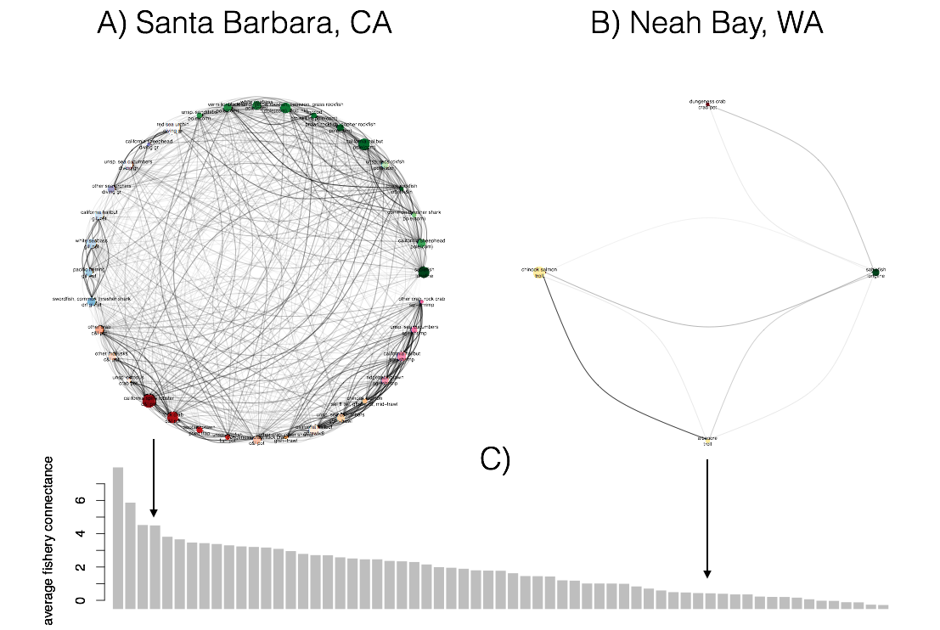

Figure 4: Estimated effects of catch shares on diversity for A) vessels and B) ports, bars are 95% confidence intervals. Vessels that participate in catch shares, increase in diversity more than either the general fleet or those that exited catch shares. At the port level the best model does not include a term for participation in catch shares, but when examined the effects are qualitatively the same despite lack of significance.

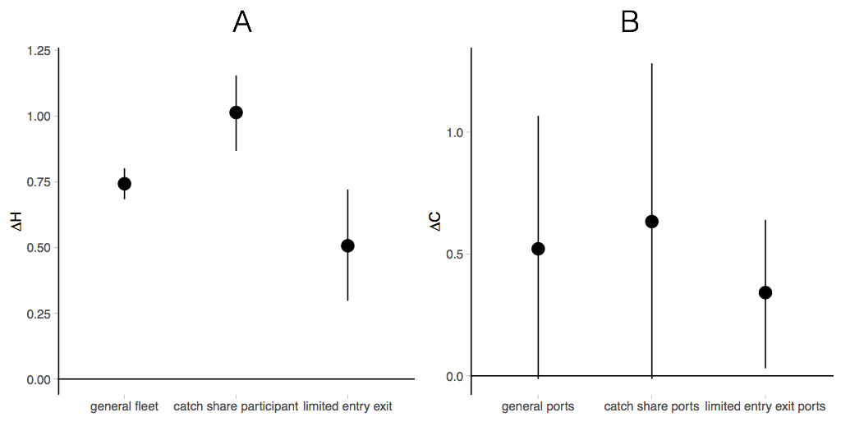

Figure 5: We map the ways that a vessel can respond to the implementation of catch shares. Vessels that were directly affected by catch share implementation are those that fished in the limited entry (LE) groundfish fleet between 2009-2010. After 2011, vessels either continue to participate in the groundfish trawl fishery by landing with quota, or leave the catch share fishery and either leave fishing entirely or continue to fish in other commercial fisheries. The width of the bar in the decision tree is proportional to the absolute number of vessels which follow a given path given by the number. Percentages are relative to each decision point.

